Name:___________________ Intro to Plate Tectonics___ Block:____________

NOTES: LAYERS OF THE EARTH
Purpose: This is a science demo intended to illustrate layering properties of fluids relative to their densities. We will relate these properties to how the earth developed a layered structure.
Part I:
What is Density?

What is the formula for density?

Part A: Calculating the densities of mystery fluids:
1.) Record the mass of the empty beakers for each fluid in the data table below
2.) Record the mass of each beaker containing the color fluid
3.) Find the mass of the fluid ONLY. (Subtract the mass of the empty beaker from the mass of the fluid + beaker together)
4.) Calculate the density of ONLY the fluid using the formula for density equation
Color of Liquid | Mass of empty beaker (g) | Mass of beaker + fluid (g) | Mass of fluid ONLY (g) | Volume of fluid (mL) | Density= mass of the fluid only/ volume of the fluid (show work) | Calculated density of fluid in g/mL
 |  |  |  | 200 mL
 |  |  |  | 200 mL
 |  |  |  | 200 mL
 |  |  |  | 200 mL

5.) PREDICT the order in which each fluid will settle when poured into the large graduated cylinder. Draw this with colored pencils to the left below AND explain your reasoning by using the density of each fluid you calculated in the data table.
Explanation: Actual Results:

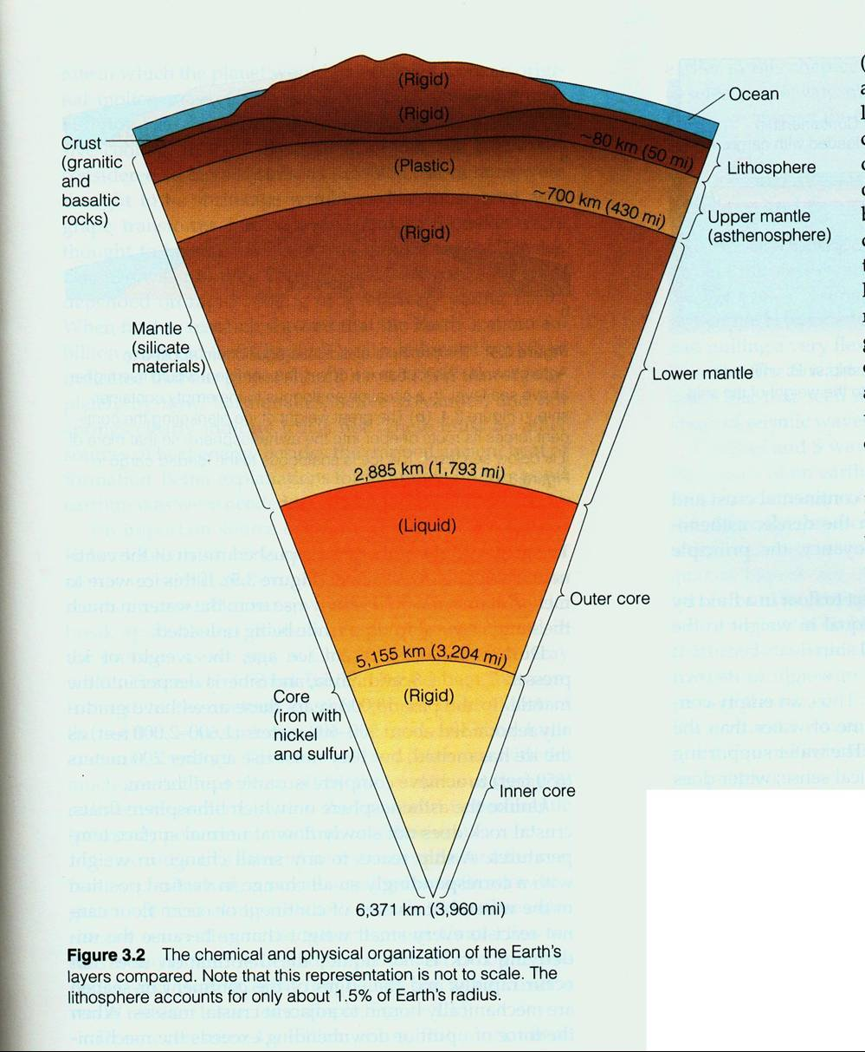
Part B: Earth’s Interior Structure

1.)Open to page 10 of your ESRT. The 4 main layers of the earth are as follows: Crust, Mantle, Outer Core, and Inner Core. These are also depicted in the image to the right.

For each of the following variables, explain how they change with an increase in depth (moving from the crust to the inner core)

- Density:

- Temperature:

- Pressure:

Key Question for Key Concept: Earth was once molten, but over many years cooled solidified and developed the four distinct layers pictured above. What property of Earth’s interior combined with a force has resulted in the Earth separating into these 4 distinct layers?

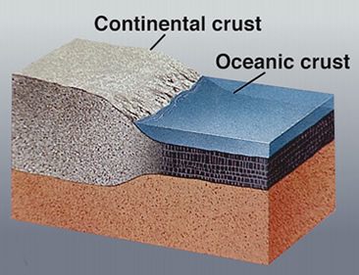

Further Subdivisions of Earth’s Interior:

Lithosphere: The lithosphere is a combination of both continental and basaltic ____________ as well as the ridged __________ ___________. The lithosphere is made of __________ rock. The continental crust (granite) has a density of __________g/cm³ and is thicker but less dense than oceanic crust (basalt) with a density of __________ g/cm³. The crust ranges in thickness from 5km (the thinnest is in the middle of the oceans) all the way to 100 km deep (on continents where the tallest mountain ranges are).
Asthenosphere: The asthenosphere is a portion of the ______________ ________________, where the rock neither behaves as a solid nor a liquid. It is said to be in a plastic state or “partially melted.” In this zone, the interior temperature is _____________ to the melting temperature rock (pg. 10 ESRT melting curves).
Moho: This is the boundary between the ____________________ and the ____________________. It was discovered when seismic waves (released from earthquakes) changed both speed and direction when traveling through the earth.
Ridged Mantle: The ridged mantle is large section of earth where the rock returns back into a complete ______________ state, as the interior temperature falls _________ the melting point. Rocks here are very high in density, mafic and are compressed under extreme pressures.
Outer Core: The outer core is made out of _____________ iron and nickel. Iron and nickel is much denser than both the mafic and silicate rocks that make up most of the earth’s crust and mantle. In this layer, the interior temperature is ______________ than the melting temperature, thus the outer core is inferred to be in a ________________ state (pg. 10 ESRT melting curves).
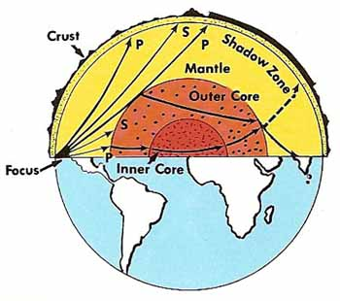
Inner Core: Like the outer core, this layer is inferred to be composed of iron and nickel, however, at these depths, pressures are extreme and the actual temperature falls ________________ the melting point, returning this layer into a ______________ state.
Evidence: How do we know what the Earth is made of?

- _______________________ ___________:They speed up when they encounter layers with greater density, and even bend, known as refraction. There is one type of wave that will not make it through liquids (will stop when they reach the outer core); S-WAVES
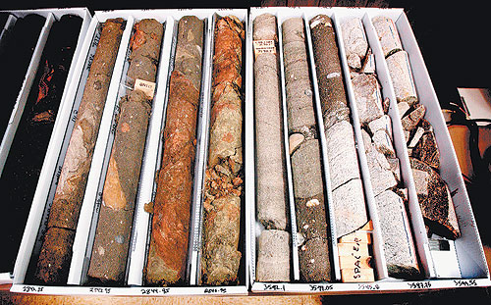
- Studying the composition of ____________________- Earth was inferred to form from large bodies of rock accreting (crashing and combining) together in the solar system over time. Meteorites found today are largely composed of iron and nickel, the densest material on earth inferred to have “sunk” toward the core.
- Studying the composition of ______________/___________ released from __________________________.
- Studying the composition of _______________from the ____________________- this provides direct evidence of what the crust is composed of, however, we have only drilled down to 12 kilometers (not even coming close to reaching the asthenosphere and beyond!)
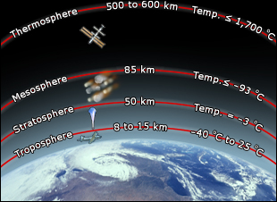
Part C: Earth’s Atmospheric Layers
Just as the interior of Earth is layered, the atmosphere is layered as well. Using the Diagram to the right, what are the four main layers of the atmosphere from the bottom upwards?

- __________________
- __________________
- __________________
- __________________
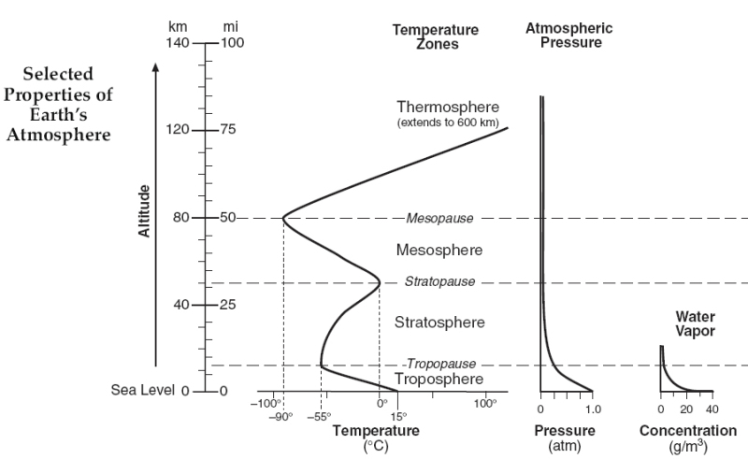
Using pg. 14 of your ESRT, we will answer some questions about the atmosphere.

Temperature: For the following layers, how does temperature change with increasing altitude?

Troposphere: ______________

Stratosphere: ______________
(*This is due to the presence of the ozone layer which absorbs UV energy!)
Mesosphere: ______________

Thermosphere: ____________
(This is due to the bombardment of high energy solar radiation from the sun interacting with molecules-
It’s filtered out by the time it reaches earth’s surface!)

Our atmosphere is divided into layers due to this marked change in ____________________ between each of the layers.

Boundaries are atmospheric layers end with the word “__________.”

Water Vapor: In order for weather to occur (cloud formation, etc.) water is required. Most of Earth’s water vapor is held under the influence of gravity in the ______________________. There is very little water vapor remaining in the ________________________ (<2 g/m³), therefore, no weather occurs there. Jet plains typically fly in the mid to upper portion of the troposphere to avoid weather.
Pressure: As one increases in altitude within the atmosphere, and through every atmospheric layer, the pressure only _____________________ with increasing altitude. Pressure here is measured in atmospheres (atm). By the time one reaches the tropopause, atmospheric pressure reaches 0.25 atmospheres (1/4 of the pressure at the surface!)

